**ASSIGNMENT-3**

**LINUX ENVIRONMENT VARIABLE**

Create a script named “myscript” in current directory to do the following.

1. create a dir named “subd1” in current directory

A: mkdir subd1

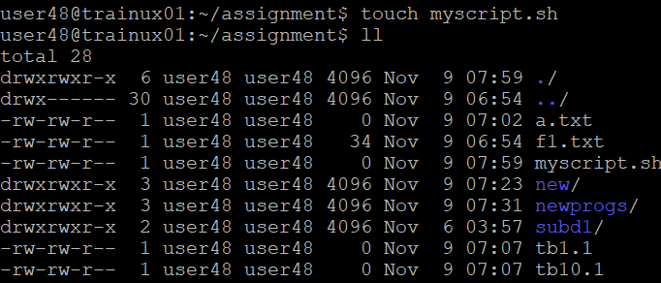

1. create a file named “dircontent” with contents of the current directory

A:

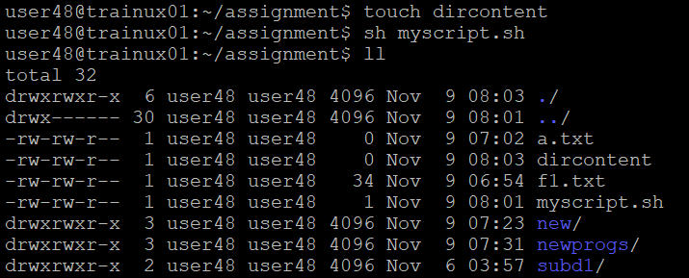

1. display the contents of the file “dircontent”

A: cat dircontent

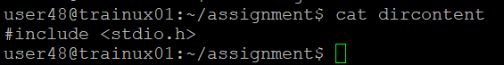

1. display the contents of a non existing file named “unknownfile”

A: cat unknownfile 2>/dev/null

2. Run the script and validate the output in following cases

a) Redirect only the stdout to an o/p file named stdout.txt

A: ./myscript > stdout.txt

b) Redirect only the stderr to an o/p file named stderr.txt

A: ./myscript 2> stderr.txt

c) Redirect both stdout and stderr to an o/p file named stdall.txt

A: ./myscript > stdall.txt 2>&1

d) Display all o/p and error and also redirect both stdout and stderr to an o/p file named stdall.txt

A: ./myscript | tee stdall.txt

./myscript 2>&1 | tee stdall.txt

3. Redirect the output of command below using pipe (|) to wc and get the output .

ls -l

A: ls -l | wc -l

